[64a] ‘Bxal’, Art-Language, Vol. 2 No. 4, June, 1974, pp. 87-125.

a 01* Simple categories (so much for speech)

There might be lots of ways to express a lot of this ... what are the advantages? We don’t have the dictionary... this is not rational ... it’s what we may want though, isn’t it?

So, down to the simple types – and drop a bit of the over-weight notation.

Accept (e. g.) that:

Xal = ‘shut’
Y = ‘your mouth’
Cal = ‘going-on’

Df. 1)
Any set (?)

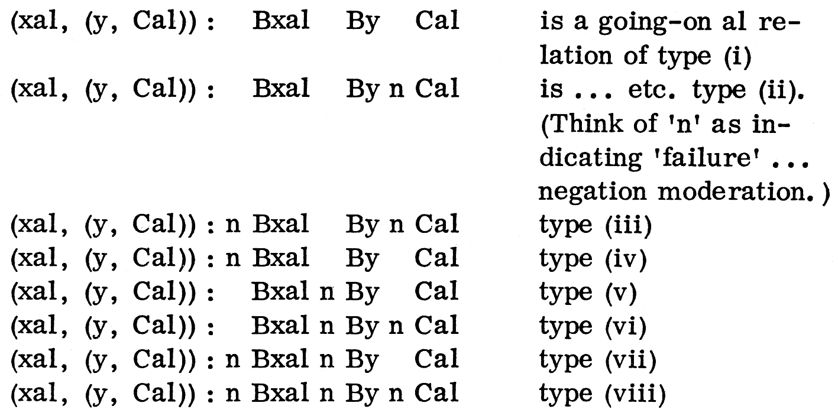

The simple types are too strong (and they’re silly in application most of the time). Don’t worry why at the moment, but a fairly exhaustive characterization of … going-on relations can be obtained from constellations of the simple types, i.e. from the schemata Bxal By Cal, Bxal By n Cal, (simplified to) Bx n By Cal, Bx n By n Cal, one can obtain 42 ‘basic types’
_____

a 02
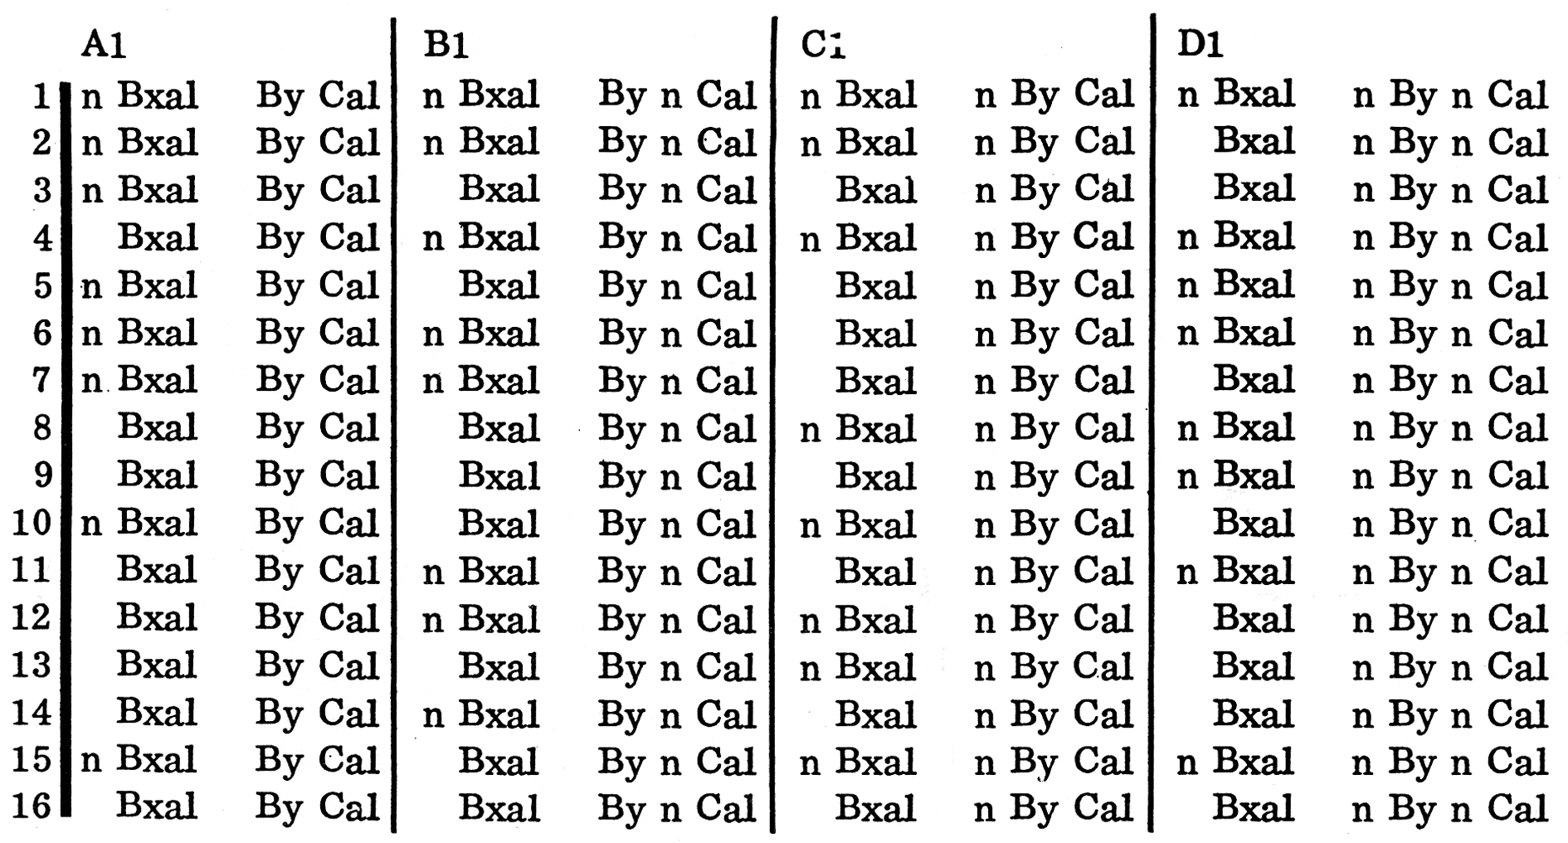

Some of the constellations are sets which don’t represent satisfiable formulae ... are we interested in satisfaction? There are other combinations: forget them. 1-6 are sets which represent satisfiable formulae. 7-16 are molecular (and) complex expressions capable of weakening 1-6 when concatenated therewith.

The application of a whole (four element) concatenation expression (‘line’) involves a structural (concatenatory) hybrid of degree 1. This indicates a mesomeric (type 1) ‘directional’ grammatical situation.
_____

a 1 (proper)

B cannot + B be Cal n B cannot + B be n Cal n B cannot + n B be Cal n B cannot + B be n Cal B cannot be + B sloganized Cal B cannot be + sloganized n Cal n B cannot be + n B sloganized Cal n B cannot B + n B sloganized n Cal

Guess which one of the following strings is a part of the next (a 2) piece of grammatical ‘information’. Make your choice, then look it up in the supplementary instruction index.

a 1. 1

B I + B don’t Cal n B I + B don’t n Cal

a 1. 2

I + Pron + Count + Person ...
_____

a 2

n B I + B don’t Cal n B I + B don’t n Cal B I + n B don’t Cal n B I + n B don’t n Cal + B I don’t + B understand n Cal B I don’t + n B understand n Cal B I don’t + B understand Cal n B I don’t + n B understand Cal

Guess which one of the following is a part of the next (a 3) piece of grammatical ‘Information’. Make your choice, then look it up in the supplementary instruction index.

a 2. 1

B ‘Darling’ + n B she said n B ‘Darling’ + B she said ...

a 2. 2

B rejection + B of Cal B rejection + B of n Cal B rejection + n B of Cal B rejection + n B of n Cal ...
_____

a 3

B rejection + B of Cal B rejection + B of n Cal B rejection n B of Cal B rejection + n B of n Cal B rejection of + n B the n Cal n B rejection of + n B the n Cal n B rejection of the + B distinction Cal B rejection of the + B distinction n Cal B rejection of the n B distinction Cal B rejection of the n B distinction n Cal

Guess which one of the following is a part of the next (a 4) piece of grammatical information. Make your choice, then look it up in the supplementary instruction index.

a 3. 1

Michael Baldwin is talking to Terry Atkinson here ...

a 3. 2

3 meanings + n B be Cal n B meanings + B be Cal ...
_____

a 4

B meanings + n B be Cal n B meanings + B be Cal B meanings B be accessible Cal n B meanings + B be accessible n Cal B meanings n B be accessible Cal B meanings + n B be accessible n Cal

Guess which one of the following is a part of the next (a 5) piece of grammatical information. Make your choice, then look it up in the supplementary instruction index.

a 4. 1

B meanings + n B be Cal n B meanings + B be Cal B meanings B be accessible ...

a 4. 2

B meanings ... B be Cal B meanings B be + n B accessible …
_____

a 5

B meanings ... B be Cal B meanings be + n B accessible Cal n B meanings be + n B accessible n Cal

Guess which one of the following is a part of the next (a 6) piece of grammatical information. Make your choice, then look it up in the supplementary instruction index.

a 5. 1

Will go-on + VB + psychological + intention + modal ... tense ... future

a 5. 2

B be + B cannot n Cal
_____

a 6

B be + B cannot n Cal

Guess which one of the following is a part of the next (a 7) piece of grammatical information. Make your choice, then look it up in the supplementary Instruction Index.

a 6. 1

B “ + B I’ll Cal n B” + I’ll B go-on Cal

a 6. 2

B “ + B …” Cal …
_____

a 7

B “+ B ...” Cal B “ + n B ...”n Cal

Guess which one of the following is a part of the next (a 8) piece of grammatical information. Make your choice, then look it up in the supplementary instruction index.

a 7. 1

B I’ll + B go-on Cal n B I’ll + n B go-on Cal B I’ll go-on + n B we’ll go-on n Cal

a 7. 2

B act of + n B faith n Cal …
_____

a 8

I’ll + x
We’ll + z
Go-on + y

Cal + B we’ll go-on
Bx + By Cal n Bx + n By Cal Bz + By Cal n Bz + n By Cal Bzy + n B unspecified n Cal

Guess which one of the following is a part of the next (a 9) piece of grammatical information. Make your choice, then look it up in the supplementary instruction index.

a 8. 1

B cannot + B be Cal n B cannot + B be n Cal ...

a 8.2

Bx + By Cal Bx + By n Cal n Bx …
_____

a 9

n B revision + B is a function Cal n B revision + B is a function n Cal n B revision + n B is a function Cal n B revision + n B is a function n Cal ...

Guess which one of the following is a part of the next (a 10) piece of grammatical information. Make your choice, then look it up in the supplementary instruction index.

a 9. 1

(xal, (y, Cal)): Bxal By n Cal

a 9. 2

Bx + By Cal Bx + By n Cal n Bx + n By Cal n Bx + n By n Cal + Bx + n Bz ...
_____

a 10

Bx + By Cal Bx + By n Cal n Bx + n By Cal n Bx n By n Cal + Ex + n Bz Cal n Ex + n Bz n Cal where Ex + Bz Cal Bx + Bz n Cal n Ex + Bz Cal n Ex n Bz n Cal

a 10. 1

Either go-on reading from where you left off, or go back to the beginning of the text and start again.
_____

Supplementary Instruction Index a

a 1. 2 Go back to the beginning of the text and start again.
a 4. 2 Go-on reading from where you left off.
a 8. 1 Go back to the beginning of the text and start again.
a 7. 1 Go back to a 5 in text and start again from there.
a 1. 1 Go-on reading from where you left off.
a 2. 1 Go back to the beginning of the text and start again.
a 4. 1 Go back to the beginning of the text and start again.
a 5. 2 Go-on reading from where you left off.
a 7. 1 Go back to to a 5 in text and start again from there.
a 3. 1 Go-on reading from where you left off.
a 4. 2 Go-on reading from where you left off.
a 3. 2 Go-on reading from where you left off.
a 9. 1 Go back to the beginning of the text and start again.
a 6. 1 Go back to the beginning of the text and start again.
a 1. 2 Go back to the beginning of the text and start again.
a 5. 1 Go-on reading from where you left off.
a 7. 2 Go back to the beginning of the text and start again.
a 2. 2 Go-on reading from where you left off.
a 8. 2 Forget about the rewrite hints in a 7; go-on reading from where you left off.
a 9. 2 Go-on reading from where you left off.
a 6. 2 Go-on reading from where you left off.
a 8. 1 Go back to the beginning of the text and start again.
_____

Instruction Index b x

Several items of grammatical/mapping information (b 1-b 13) are undexed in the transcript text (b 001). These items (b-b 13) should be referred to in the same order as they are indexed in the text one at a time. (For example, b 1 should be referred to when it is indexed in b 001 and replaced before going-on to b 2 ... and so on.) Where an item is indexed more than once, and (in the first instance) in the same place as one of a lower order, it should be referred to (and its pathway followed, etc.) alternately as the pathway of its fellow reaches the next index point. Each occurrence of an index letter and number is to be regarded as discrete with respect to any other, i.e. a grammatical/mapping item is to be referred to and its pathway followed independently every time it is indexed in the text (b 001).
_____

b 001

I was really concerned to voice a few feelings about book
learning and a few reservations about what we mean typically
by ‘structure’ with respect to our discourse. I’ve [b 1]
wanted to consider ways of being concerned to map some
of these reservations onto the function sets dealing with
the problem of ideology. The problem is, I feel, not to
be addressed in a conventional locus of structurism.
Ideology is not something we can merely revise ... it is
only a set of reverberative conditions that is pervading
our experience. [b 2]

To regard discourse as something which is revised in the
way we revise involves a notion regarded very desperately
by ‘logic’. In relation to this sort of problem (which is
both historical and methodological) one would want to map
epistemological universes, etc. ... which are perhaps [b 3, b 7]
to some extent related to (like) ‘how much congruence is
expressed in these set conditions?’, ‘what if anything is
this revision?’ and ‘what are a few outside suggestions?’
We have replaced angst with the grammar of going-on
(concatenation) Cal. [b 4]

And what is, if you like, the interest in problematic in
relation to the profounder content of the concatenation? [b 5, b 6,
What is outside suggestability? This and a number of b 3]
other issues are at hand. We’d better start thinking around
a question (which is situationally very broad). How is it
that we regard ourselves, or, if you like, how is it that we
regard our discourse as in any way structural? [b 7]

One thing I might point out parenthetically is that Koestler
quote of Terry’s ... The apparent derisive frame of mind
is all shit. (I mean waves, speed, the like can be dealt
with in terms of resonance and other fairly homely sorts
of ideas.) And it seems to me that worrying about historical
perplexities (which, faute de mieux, all the methodological
perplexities of apparent scientific development add
up to) is trivial ... with respect to one’s being able to deal [b 8, b 12]
with whatever possibility of activity (qua homo religiosius)
one has. [b 9, b 4]

Now, the typical idea behind the idea of structure is that
the notion of a cardinally accessible whole is epistemologically
normal. Activity is restricted to the consideration [b 10, b 6]
of relations between parts in the finite system. It seems
to me that if we’re mapping with a ceteris paribus of the
notion ‘whole’, the only mode that we have is in fact expressed
as an heuristic dynamic based on whatever teleological
assumptions are made, instantiated – ‘lived’, as
it were – in relation to whatever existentializing set conditions
there may be. We might be able to regard (e.g.) [b 11]
teleology as characterized in some sense by the formalizables/
formalizings (in some limited degree) as they
appear in relation to set conditions, universes of discourse. [b 12, b5]
But are they characterized by formal relations among these
parts? Then what could be regarded as constituting a [b 13]
structural formula? Now, we don’t have structural formulae,
we have what are fondly regarded as malformations
… only approaching the conditions of satisfaction ... as
… formed.

_____

b O1 Read (1) ‘B shut al B your mouth Cal’ as ‘the blurting production of “shut” as discourse indexed al blurtingly produces “your mouth” as discourse indexed al ... and described as “going-on” in al’.

(Elegance here, what about order?)

From this, accept that it’s natural to interpret (1) (malformed formula) as a statement to the effect that ‘shut’ is an (early) first-place member of (this) talking-to-each-other (go-on) relation, and ‘your mouth’ is a second-(later) place member thereof. Sometimes we might want to call or think of later-place members as ‘transformation subjects al’.
_____

b 01* Simple categories (so much for speech)

There might be lots of ways to express a lot of this … what are the advantages? We don’t have the dictionary ... this is not rational ... it’s what we may want though, isn’t it?

So, down to the simple types – and drop a bit of the over-weight notation.

Accept (e.g.) that:

Xal = ‘shut’
Y = ‘your mouth’
Cal = ‘going… on’

Df. 1)
Any set (?)

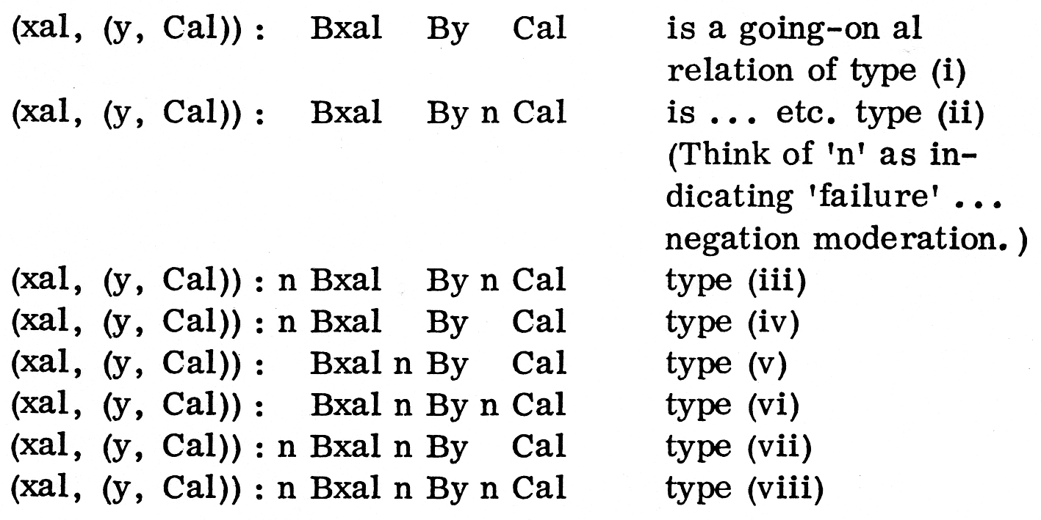

The simple types are too strong (and they’re silly in application most of the time). Don’t worry about why at the moment, but a fairly exhaustive characterization of ... going-on relations can be obtained from constellations of the simple types, i.e. from the four schemata Bxal By Cal, Bxal By n Cal, (simplified to) Bx n By Cal, Bx n By n Cal, one can obtain 42 ‘basic types’.
_____

b 02

Some of the constellations are sets which don’t represent satisfiable formulae ... are we interested in satisfaction? There are other combinations: forget them. 1-6 are sets which represent satisfiable formulae. 7-16 are molecular (and, complex expressions capable of weakening 1-6 when concatenated therewith.

The application of a whole (four element) concatenation expression (‘line’) involves a structural (concatenatory) hybrid of degree 1. This indicates a mesomeric (type 1) ‘directional’ grammatical situation.
_____

b 03 An additional concatenatory relation (hybrid of degree 2) is introduced. It is indicated by ‘H’ in the concatenatory expression. The structural hybridity here reflects a tactic ‘reversability’ (i.e. the teleological ‘drag’ of the second-place member) of a given pair – there being postulated a degree of tactical contingency (‘accidit-ness’) in the first-place member.

b 03. 1

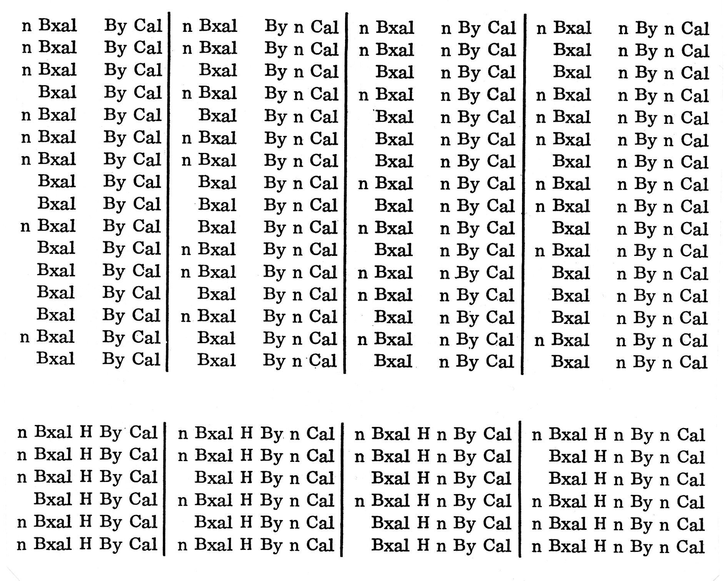
_____

b 04 Modality List

This is as picturesque as possible.

M1. Commit One to Rampton
M2. Ideology Revision/Ideology Possibility
M3. Get through this Hiatus
M4. Sociality/Socialization
M5. Dialogic Good Faith/Bad Faith
M6. Having a Problem: Seeing One’s Situation as Problematic
_____

b 1 (proper) – emic fragments (pairing members) are assigned (guess) modalities. These are Index sets of a kind.

… I was (M3) ... really concerned (M3, M4) ...

Guess which one of the following strings is a part of the next (b 2) piece of grammatical mapping (modality mapping). Make your choice, then look it up in the supplementary instruction index.

b 1. 1 The various (complex) concatenation set (expressions) 1-16 ABCD may be assigned ‘ideology/teleology’ modalities.

b 1.2 ... I was (M5, M6, M7) ... really concerned (M5, M6…) …
_____

b 2 The various (complex) concatenation set (expressions) 1-16 ABCD may be assigned ‘ideology/teleology’ modalities.

M4
n B I was (M3) + B really concerned (M3, M4) Cal, n B I was (M3) + B really concerned (M3, M4) n Cal, n B I was (M3) + n B really concerned (M3, M4) Cal, n B I was (M3) + n B really concerned (M3, M4) n Cal,

M6
n B I was (M3) + B really concerned (M3, M4) Cal, n B I was (M3) + B really concerned (M3, M4) n Cal, n B I was (M3) + n B really concerned (M3, M4) Cal, B I was (M3) + n B really concerned (M3, M4) n Cal,

M3
n B I was (M3) + B really concerned (M3, M4) Cal, B I was (M3) + B really concerned (M3, M4) n Cal, B I was (M3) + n B really concerned (M3, M4) Cal, B I was (M3) + n B really concerned (M3, M4) n Cal,

M3
n B I was (M3) + B really concerned (M3, M4) Cal, n B I was (M3) + B really concerned (M3, M4) n Cal, B I was (M3) + n B really concerned (M3, M4) Cal, B I was (M3) + n B really concerned (M3, M4) n Cal.

Guess which one of the following strings is a part of the next (b 3) piece of grammatical mapping (modality mapping). Make your choice, then look it up in the supplementary instruction index.

b 2. 1 The topic modalities here indicated for each set (expression) are ‘weak’ with respect to specificity. The concatenation weakening (‘out-of-the-blue’) expressions are richer, i.e. complex topic modality hybrids.

b 2. 2 (Ml)... I was (M3, M4) ... really concerned (M3, M4)... I was...
_____

b 3 The topic modalities here indicated for each set (expression) are ‘weak’ with respect to specificity. The concatenation weakening (‘out-of-the-blue’) expressions are richer, i.e. complex topic modality hybrids.

Expressions of the ‘H’ group are different from 1-6 (from which they are derived) as to modality index.

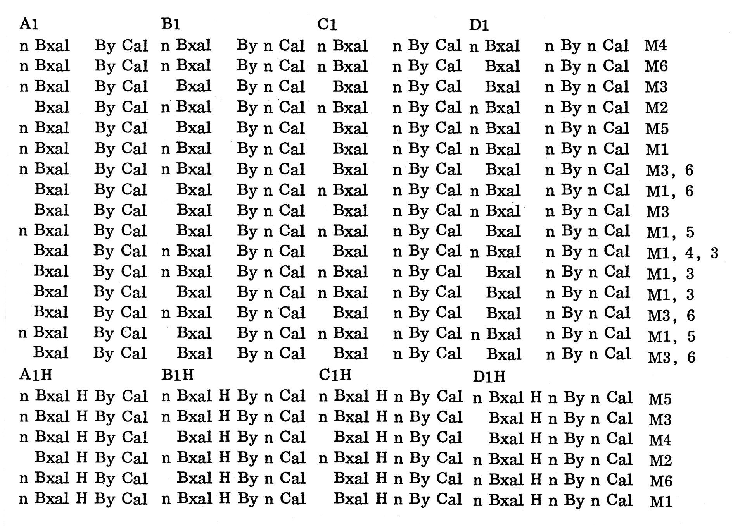

Guess which one of the following strings is a part of the next (b 4) piece of grammatical mapping (modality mapping). Make your choice, then look it up in the supplementary instruction index.

b 3. I n B was really (Ml, M2) + B concerned to (Ml) Cal, n B was really (Ml, M2) + B

b 3. 2 Really — Adv — Degree — Quantify — ...
_____

b4

M6
n B was really (Ml, M2) + B concerned to (Ml) Cal, n B was really (Ml, M2) + B concerned to (Ml) n Cal, n B was really (Ml, M2) + n B concerned to (Ml) Cal, n B was really (Ml, M2) + n B concerned to (Ml) n Cal,

M2
n B was really (Ml, M2) + B concerned to (Ml) Cal, n B was really (Ml, M2) + B concerned to (Ml) n Cal, n B was really (Ml, M2) + B concerned to (Ml) Cal, B was really (Ml, M2) + n B concerned to (Ml) n Cal,

M1
n B was really (Ml, M2) + B concerned to (Ml) Cal, B was really (Ml, M2) + B concerned to (Ml) Cal, n B was really (Ml, M2) + n B concerned to (Ml) Cal, n B was really (Ml, M2) + n B concerned to (Ml) n Cal,

M3
B was really (Ml, M2) + B concerned to (Ml) Cal, B was
M6
really (Ml, M2) + B concerned to (Ml) n Cal, B was really (Ml, M2) + n B concerned to (Ml) Cal, B was really (Ml, M2) + n B concerned to (Ml) n Cal.

Guess which one of the following strings is a part of the next (b 5) piece of grammatical mapping (modality mapping). Make your choice, then look it up in the supplementary instruction index.

b 4. 1 Really — Adv — Degree — Quantify

b 4. 2 n B I was really (Ml, M3, M6) + B concerned to voice (Ml, M3, M6) Cal, n B I was really (M1, M3, M6) + B concerned to voice (Ml, M3, M6) n Cal ...
_____

b 5

M4
n B I was really (Ml, M3, M6) + B concerned to voice (Ml, M3, M6) Cal, n B I was really (Ml, M3, M6) + B concerned to voice (Ml, M3, M6) n Cal, n B I was really (Ml, M3, M6) + n B concerned to voice (Ml, MS,. M6) Cal, n B I was really (Ml, M3, M6) + n B concerned to voice (Ml, M3, M6) n Cal,

M6
n B I was really (...) + B concerned to voice (...) Cal, n
B I was really (...) + B concerned to voice (...) n Cal, n
B Iwas really (...) + n B concerned to voice (...) Cal, B
I was really (e..) + n B concerned to voice (...) n Cal,

M5
n B I was really (...) + B concerned to voice (…) Cal, B
I was really (…) + B concerned to voice (…) n Cal, B I
was really (…) + n B concerned to voice (…) Cal, n B I
was really (…) + n B concerned to voice (…) n Cal,

M1
B I was really (...) + B concerned to voice(...) Cal, B I
M6
was really (...) + B concerned to voice (...) n Cal, B I
was really (…) + n B concerned to voice (...) Cal, n B
I was really (…) + n B concerned to voice (...) n Cal,

n B I was really (…) H + B concerned to voice (…) Cal,
n B I was really (…) H + B concerned to voice (…) n Cal,
B I was really (…) H + n B concerned to voice (…) Cal,
n B I was really (…) H + n B concerned to voice (…) n Cal,

Guess which one of the following strings is a part of the next (b 6) piece of grammatical mapping (modality mapping). Make your choice, then look it up in the supplementary instruction index.

B 5. l n Bxal By Cal Bxal By n Cal Bxal n By Cal Bxal n By n Cal

b 5. 2 A whole concatenation expression can be assigned an ‘M’ Index: things get clearer, perhaps as items get ‘grosser’.
_____

b 6 A whole concatenation expression can be assigned an ‘M’ index: things get clearer, perhaps as items get ‘grosser’.

M3

M4
n B I was really (Ml, M3, M6) + B concerned to voice (Ml, M3, M6) Cal, n B I was really (Ml, M3, M6) + B concerned to voice (Ml, M3, M6) n Cal, n B I was really (Ml, M3, M6) + n B concerned to voice (Ml, M3, M6) Cal, n B I was really (Ml, M3, M6) + n B concerned to voice (Ml, M3, M6) n Cal,

M6
n B l was really (...)+ B concerned to voice (...) Cal, n B
I was really (…) + B concerned to voice (...) n Cal, n B I
was really (…) + n B concerned to voice (...) Cal, B I was
really (…) + n B concerned to voice (...) n Cal,

M5
n B I was really (...) + B concerned to voice (…) Cal, n B I
was really (…) + B concerned to voice (...) n Cal, B I was
really (...) + n B concerned to voice (...) Cal , n B l was
really (…) + n B concerned to voice (...) n Cal,

M1
B I was really (...) + B concerned to voice (...) Cal, B I

M6 was really (…) + B concerned to voice (...) n Cal, n B I was
really (…) + n B concerned to voice (…) Cal, n B I was
really (…) + n B concerned to voice (...) n Cal,

n B I was really (...) H + B concerned to voice (...) Cal,
n B I was really (...) H + B concerned to voice (. ..) n Cal,
B I was really (...) H + n B concerned to voice (...) Cal,
n B I was really (...) H + n B concerned to voice (...) n Cal.

Guess which one of the following strings is a part of the next (b 7) piece of grammatical mapping (modality mapping). Make your choice, then look it up in the supplementary instruction index.

b 6. 1 ‘I was really concerned to voice’: what this is about is…

b 6. 2

M2

M6
n B I was really (M4, M5, M6) + B concerned to voice (M4, M5, M6) Cal, n B I was really (M4, M5, M6) + B concerned to voice (M4, M5, M6) n Cal…

b 6. 1 Go back to b 01* and start again from there.
_____

b 7

M2

M6
n B I was really (M4, M5, MO) + B concerned to voice (M4, M5, M6) Cal, n B I was really (M4, M5, M6) + B concerned to voice (M4, M5, M6) n Cal, n B I was really (M4, M5, M6) + n B concerned to voice (M4, M5, M6) Cal, B I was really (M4, M5, M6) + n B concerned to voice (M4, M5, MO) n Cal,

M2
B I was really (M4, M5, MO) + B concerned to voice (M4, M5, MO) Cal, n B I was really (M4, M5, MO) + B concerned to voice (M4, M5, M6) n Cal, n B I was really (M4, M5, MO) + n B concerned to voice (M4, M5, M6) Cal, n B I was really (M4, M5, MO) + B concerned to voice (M4, M5, MO) n Cal,

M3
B I was really (M4, M5, M6) + B concerned to voice (M4, MO M5, MO) Cal, B I was really (M4, M5, MO) + B concerned to voice (M4, M5, MO) n Cal, B I was really (M4, M5, MO) + n B concerned to voice (M4, M5, MO) Cal, B I was really (M4, M5, MO) + n B concerned to voice (M4, M5, M6) n Cal,

M1
n B I was really (M4, M5, MO) H + B concerned to voice (M4, M5, MO) Cal, n B I was really (M4, M5, MO) H + B concerned to voice (M4, M5, MO) n Cal, B I was really (M4, M5, MO) H + n B concerned to voice (M4, M5, M6) Cal, n B I was really (M4, M5, MO) H + n B concerned to voice (M4, M5, MO) n Cal.

This is absurd.

Guess which one of the following strings is a part of the next (b 8) piece of grammatical mapping (modality mapping). Make your choice, then look it up in the supplementary instruction index.

b 7. 1

M2

M3
n B I was really (M3, M4) + B concerned to voice (M3, M4) Cal ...

b 7. 2

M2

M5
n B I was really (Ml, M5) + B concerned to voice (Ml, M5) Cal, B I was really (Ml, M5) + B concerned to voice (Ml, M5) n Cal ...
_____

b8

M2

M3
n B I was really (M3, M4) + B concerned to voice (M3, M4) Cal, n B I was really (M3, M4) + B concerned to voice (M3, M4) n Cal, B I was really (M3, M4) + n B concerned to voice (M3, M4) Cal, B I was really (M3, M4) + n B concerned to voice (M3, M4) n Cal,

M1
n B I was really (M3, M4) + B concerned to voice (M3, M4) Cal, n B I was really (M3, M4) + B concerned to voice (M3, M4) n Cal, B I was really (M3, M4) + n B concerned to voice (M3, M4) Cal, n B I was really (M3, M4) + n B concerned to voice (M3, M4) n Cal,

M3
B I was really (M3, M4) + B concerned to voice (M3, M4)

M6
Cal, n B I was really (M3, M4) + B concerned to voice (M3, M4) n Cal, B I was really (M3, M4) + n B concerned to voice (M3, M4) Cal, B I was really (M3, M4) + n B concerned to voice (M3, M4) n Cal,

M2
B I was really (M3, M4) H + B concerned to voice (M3, M4) Cal, n B I was really (M3, M4) H + B concerned to voice (M3, M4) n Cal, n B I was really (M3, M4) H + n B concerned to voice (M3, M4) Cal, n B I was really (M3, M4) H + n B concerned to voice (M3, M4) n Cal.

Guess which one of the following strings is a part of the next (b 0) piece of grammatical mapping (modality mapping). Make your choice, then look it up in the supplementary instruction index.

b 8. 1

M3

M4
n B I was really concerned to voice (…) + B a few feelings about book learning (...) Cal.

b 8.2

M5
… I was (M3) … really concerned (M3, M1) …
_____

b9

M3

M4
n B I was really concerned to voice (...) + B a few feelings about book learning (...) Cal, n B I was really concerned to voice (...) + B a few feelings about book learning (...) n Cal, n B I was really concerned to voice (...) + n B a few feelings about book learning (...) Cal, n B I was really concerned to voice (...) + n B a few feelings about book learning (...) n Cal,

M1
n B I was really concerned to voice (...) + B a few feelings about book learning (...) Cal, n B I was really concerned to voice (...) + B a few feelings about book learning (...) n Cal, B I was really concerned to voice (...) + n B a few feelings about book learning (...) Cal, n B I was really concerned to voice (...) + n B a few feelings about book learning (...) n Cal,

M1
n B I was really concerned to voice (...) H + B a few feelings about book learning (...) Cal, n B I was really concerned to voice (...) H + B a few feelings about book learning (...) n Cal, B I was really concerned to voice (...) H + n B a few feelings about book learning (...) Cal, n B I was really concerned to voice (...) H + n B a few feelings about book learning (...) n Cal.

Guess which one of the following strings is a part of the next (b 10) piece of grammatical mapping (modality mapping). Make your choice, then look it up in the supplementary instruction index.

b 9.1

M3

M4
n B I was really concerned to voice (M3, M4, M6) + B a few feelings about book learning (M3, M4, M6) Cal ...

b 9. 2 n B I was really concerned to voice (M2) + B a few feelings about book learning (M2) Cal…
_____

b 10

M3

M4
n B I was really concerned to voice (M3, M4, M6) + B a few feelings about book learning (M3, M4, M6) Cal, n B I was really concerned to voice (M3, M4, M6) + B a few feelings about book learning (M3, M4, M6) n Cal, n B I was really concerned to voice (M3, M4, M6) + n B a few feelings about book learning (M3, M4, M6) Cal, n B I was really concerned to voice (M3, M4, M6) + n B a few feelings about book learning (M3, M4, M6) n Cal,

M1
n B I was really concerned to voice (M3, M4, M6) + B a few feelings about book learning (M3, M4, M6) Cal, n B I was really concerned to voice (M3, M4, M6) + B a few feelings about book learning (M3, M4, M6) n Cal, B I was really concerned to voice (M3, M4, M6) + n B a few feelings about book learning (M3, M4, M6) Cal, n B I was really concerned to voice (M3, M4, M6) + n B a few feelings about book learning (M3, M4, M6) n Cal,

M1
n B I was really concerned to voice (M3, M4, M6) H + B a few feelings about book learning (M3, M4, M6) Cal, n B I was really concerned to voice (M3, M4, M6) H + B a few feelings about book learning (M3, M4, M6) n Cal, B I was really concerned to voice (M3, M4, M6) H + n B a few feelings about book learning (M3, M4, M6) Cal, n B I was really concerned to voice (M3, M4, M6) H + n B a few feelings about book learning (M3, M4, M6) n Cal.

Guess which one of the following strings is a part of the next (b 11) piece of grammatical mapping (modality mapping). Make your choice, then look it up in the supplementary instruction index.

b 10. 1

M2

M2
B we’d better (M2, M3, M6) + B start thinking (M2, M3, M6) Cal…

b 10. 2

M3

M4
n B I was really concerned to voice (...) + B a few feelings about book learning (...)
Cal ...
_____

b 11

M2

M2
B we’d better (M2, M3, M6) + B start thinking (M2, M3, M6) Cal, n B we’d better (M2, M3, M6) + B start thinking (M2, M3, M6) n Cal, n B we’d better (M2, M3, M6) + n B start thinking (M2, M3, M6) Cal, n B we’d better (M2, M3, M6) + n B start thinking (M2, M3, M6) n Cal,

M1
n B we’d better (M2, M3, M6) + B start thinking (M2, M3, M6) Cal, n B we’d better (M2, M3, M6) + B start thinking (M2, M3, M6) n Cal, B we’d better (M2, M3, M6) + n B start thinking (M2, M3, M6) Cal, n B we’d better (M2. M3, M6) + n B start thinking (M2, M3, M6) n Cal,

M2
n B we’d better (M2, M3, M6) H + B start thinking (M2, M3, M6) Cal, n B we’d better (M2, M3, M6) H + B start thinking (M2, M3, M6) n Cal, n B we’d better (M2, M3, M6) H + n B start thinking (M2, M3, M6) Cal, B we’d better (M2, M3, M6) H + n B start thinking (M2, M3, M6) n Cal.

Guess which one of the following strings is a part of the next (b 12) piece of grammatical mapping (modality mapping). Make your choice, then look it up in the supplementary instruction index.

b 11. 1

M2

M2
B we’d better start thinking (M2, M3, M6) + B around a problem (M2, M3, M6) Cal, n B we’d better start thinking (M2, M3, M6) + B around a problem (M2, M3, M6) n Cal…

b 11. 2

M2

M5
n B we’d better start thinking (M2, M3, M6) + B around a problem (M2, M3, M6) Cal, B we’d better start thinking (M2, M3, M6) + B around a problem (M2, M3, M6) n Cal…
_____

b 12

M2

M2
B we’d better start thinking (M2, M3, M6) + B around a problem (M2, M3, M6) Cal, n B we’d better start thinking (M2, M3, M6) + B around a problem (M2, M3, M6) n Cal, n B we’d better start thinking (M2, M3, M6) + n B around a problem (M2, M3, M6) Cal, n B we’d better start thinking (M2, M3, M6) + n B around a problem (M2, M3, M6) n Cal,

M1
n B we’d better start thinking (M2, M3, M6) + B around a problem (M2, M3, M6) Cal, n B we’d better start thinking (M2, M3, M6) + B around a problem (M2, M3, M6) n Cal, B we’d better start thinking (M2, M3, M6) + n B around a problem (M2, M3, M6) Cal, n B we’d better start thinking (M2, M3, M6) + n B around a problem (M2, M3, M6) n Cal,

M6
B we’d better start thinking (M2, M3, M6) + B around a problem (M2, M3, M6) Cal, B we’d better start thinking (M2, M3, M6) + B around a problem (M2, M3, M6) n Cal, B we’d better start thinking (M2, M3, M6) + n B around a problem (M2, M3, M6) Cal, B we’d better start thinking (M2, M3, M6) + n B around a problem (M2, M3, M6) n Cal,

M2
n B we’d better start thinking (M2, M3, M6) H + B around a problem (M2, M3, M6) Cal, n B we’d better start thinking (M2, M3, M6) H + B around a problem (M2, M3, M6) n Cal, n B we’d better start thinking (M2, M3, M6) H + n B around a problem (M2, M3, M6) Cal, n B we’d better start thinking (M2, M3, M6) H + n B around a problem (M2, M3, M6) n Cal.

Guess which one of the following strings is a part of the next (b 13) piece of grammatical mapping (modality mapping). Make your choice, then look it up in the supplementary instruction index.

b 12. 1

M1

M2
B A B C D E (...) + B F G H I J (...) Cal

b 12. 2

M2

M6
n B discourse as in any way (...) + B structural (...) Cal,
n B discourse as in any way (...) + B structural (...) n Cal
_____

b 13

M6

M2
n B discourse as in any way (…) + B structural (…) Cal, n B discourse as in any way (…) + B structural (…) Cal, n B discourse as in any way ( …) + n B structural (…) Cal, B discourse as in any way (…) + n B structural (…) n Cal,

M3
n B discourse as in any way (...) + B structural (...) Cal, B discourse as in any way (...) + B structural (...) n Cal, B discourse as in any way (...) + n B structural (...) Cal, n B discourse as in any way (...) + n B structural (...) n Cal,

M3
B discourse as in any way (...) + B structural (…) Cal, B discourse as in any way (…) + B structural (…) n Cal, B discourse as any way (…) + n B structural (…) Cal, n B discourse as in any way (…) + n B structural (…) n Cal,

M4
n B discourse as in any way (...) H + B structural (...) Cal, B discourse as in any way (...) H + B structural (...) n Cal, B discourse as in any way (...) H + n B structural (...) Cal, n B discourse as in anyway (...) H + n B structural (...) n Cal.

b 13. i Either go-on reading from where you left off or go back to the beginning of the text and start reading again.
_____

Supplementary Instruction Index b 014

b 3. 2 Go back to the beginning of the text and start again.
b 4. 2 Go-on reading from where you left off.
b 2. 2 Go back to the beginning of the text and start again.
b 10. 2 Go back to b 3 and start again from there.
b 7. 2 Go back to b 5 and start again from there.
b 11. 2 Go back to the beginning of the text and start again.
b 2. 1 Go-on reading from where you left off.
b 1.2 Go back to the beginning of the text and start again.
b 9.2 Go back to b 5 and start again from there.
b 6.2 Go-on reading from where you left off.
b 8. 2 Go back to b 5 and start again from there.
b 5. 2 Go back to b 4 and start again from there.
b 11. 1 Go back to b 10 and start again from there.
b 8. 1 Go back to b 7 and start again from there.
b 9.1 Go-on reading from where you left off.
b 1. 1 Go-on reading from where you left off.
b 3. 1 Go-on reading from where you left off.
b 12. 2 Go back to b 7 and start again from there.
b 5. 1 Go back to b 01 and start again from there.
b 7. 1 Go-on reading from where you left off.
b 12. 2 Go back to b 7 and start again from there.
b 4. 1 Go back to b 01 and start again from there.
b 10. 1 Go back to b 9 and start again from there.
_____

The statement that there is a body of dialectical discourse (activity) which is not soul-marginal has to be interpreted as meaning that there is actually a case in which an item of dialectical discourse (activity) dd in the virtual domain Dd is satisfied, where dd is such that the conditional dialogical strength c (Xs/dd) gives an equal dialogical strength to all possible specific soul-marginal items Xs.

The statement that there is a body of soul-marginal discourse (activity) which is not dialectical has to be interpreted as meaning that there is actually a case in which an item of soul-marginal discourse (activity) ds in the domain Ds is satisfied, where ds is such that the conditional dialogical strength c (Xd/ds) gives an equal dialogical strength to all possible specific dialectical items Xd.

The statement that there is a body of dialectical discourse (activity) which is not soul-marginal has to correspond to a dialectical statement dd in the virtual domain Dd such that the conditional dialogical strength c (Xs/dd) gives a concentrated weight on a certain region of the soul-marginal spectrum.

The statement that there is a body of soul-marginal discourse (activity) which is dialectical has to correspond to a soul-marginal statement ds in the domain Ds such that the conditional dialogical strength c (Xd/ds) gives a concentrated weight on a certain region of the dialectical spectrum.

Postulate I
Going-on occasionally composes the structure of a lattice Lg. This is to say that it involves a continuously infinite number of propositions and the idea that the number of elements which may be simultaneously conjoined is finite. Dialectical discourse (activity) may be a (Boolean) sublattice Ld of the greater lattice. Soul-marginal discourse (activity) is another Ls.

Postulate II
The two subsets have only two common elements – constant absurdity and truism (teehee, yawn respectively). This is a rejection of the idea that a dialectical item is equivalent to a soul-marginal one.

Postulate III
The conjunction of a dialogical item (≠ yawn) and a soul-marginal one (≠ yawn) may have a meaning (not necessarily a constant absurdity or a truism) except in the case in which it becomes a constant absurdity.

The disjunction of a dialectical item (≠ teehee) and a soul-marginal one (≠ teehee) has a meaning (not necessarily a constant absurdity or a truism) but this is neither a dialectical item nor a soul-marginal one except in the case in which it becomes a constant truism.

